**Deng Solutions Pvt. Ltd.**



**Introduction**

Deng Solutions have been an established and popular solution provider in Bhopal Madhya Pradesh India. Our work record is excellent for the customer satisfaction in our field. Main goal of our work is to provide high quality solution with services to our customers. In order to make our customer happy solutions are provide at very competent price. Our team provides an excellent set of ideas for optimizing customer solutions.

**Services**

We provide solutions in two fields first is education and second is industrial. Our contribution in education field is from 2011. While in Industrial requirement our contribution is from 2015. Different solution and services in these fields are:

**Home Page:** This shows About Us, Notice, News, Events, School Features , Video, Toppers List, Tutor. Footer have address, important links, Social links.

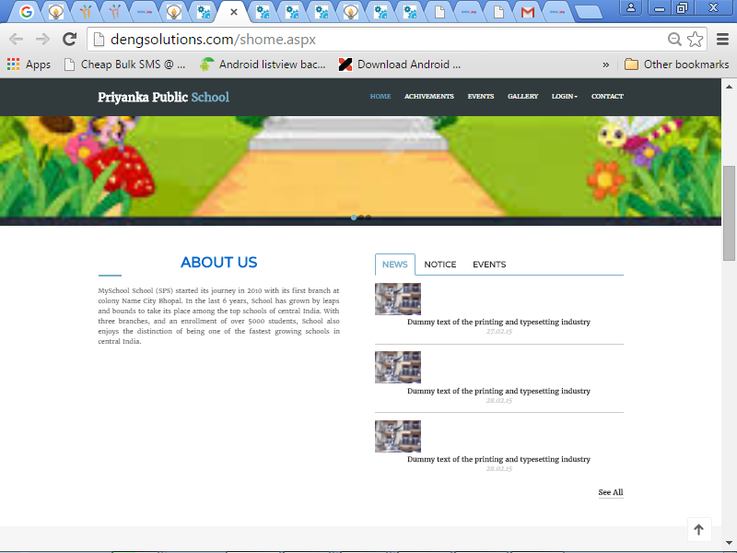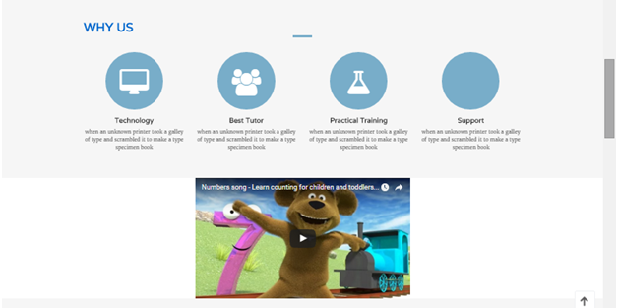

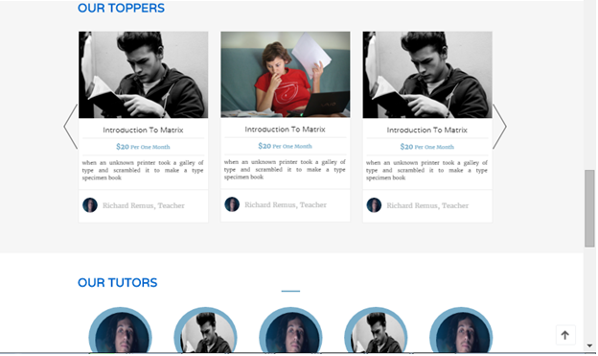

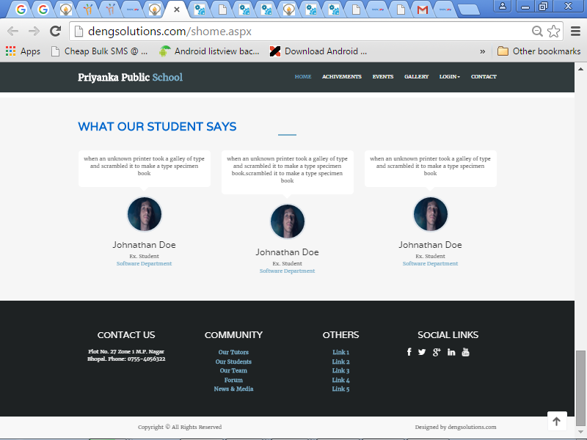

**Events Page:** Shows List of events with Name, Time, Location and description. Here One can add or delete these control from the Admin part of the website.

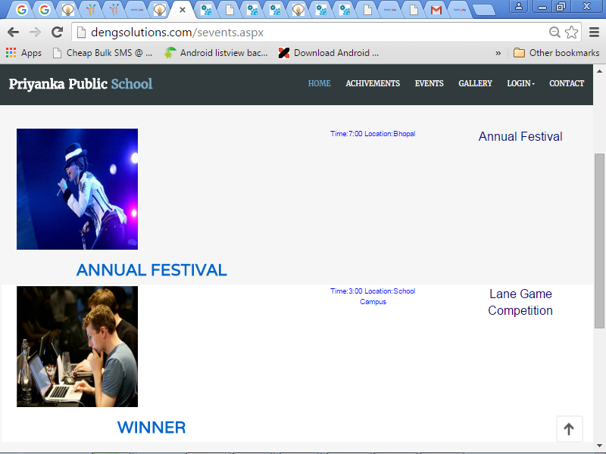

**Gallery Page:** Shows List of Images. Here One can add or delete these control from the Admin part of the website.

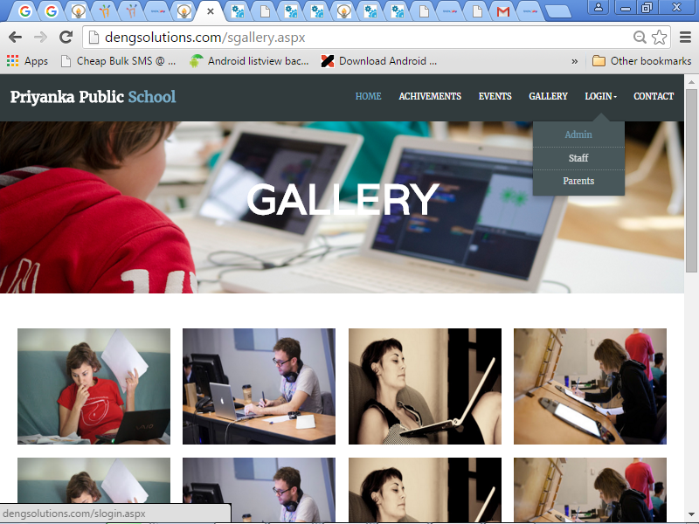

**Admin Login Page:**

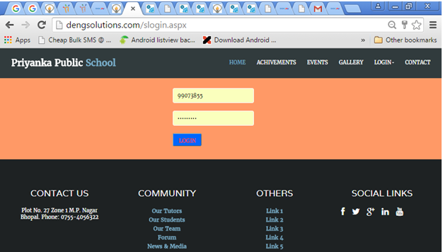

**Admin Controls:** Controls are divide into five categories.

1. Student (Admission, Attendance, Result, Edit Data, Front Pages, Add Subjects, Messages)

2. Staff (Joining, Permission, Attendance, Shifts, Lectures, Time Table)

3. Library (Add Book, Issue, submit, Edit Book)

4. Accounts (Credit, Debit, Daily Transaction, Student Transaction

5. Marketing (Data Form, Tele-caller, Executive View, Edit Data)

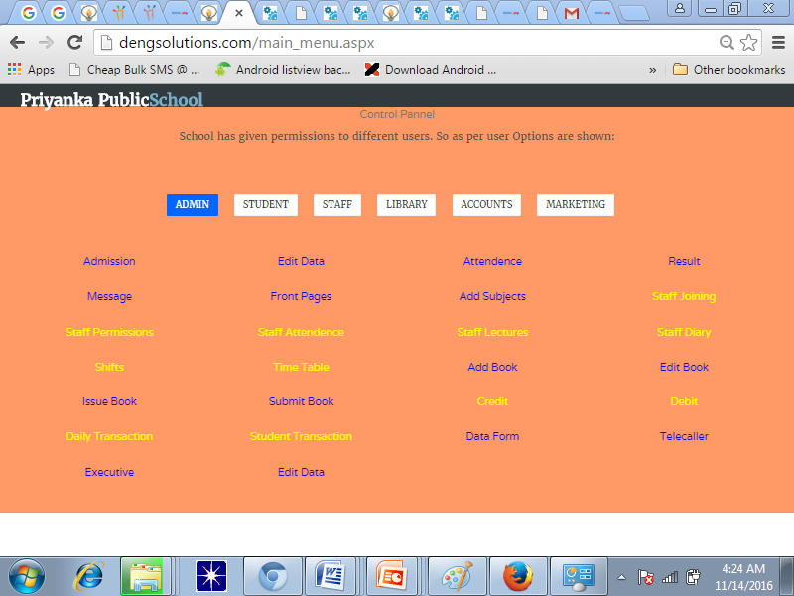

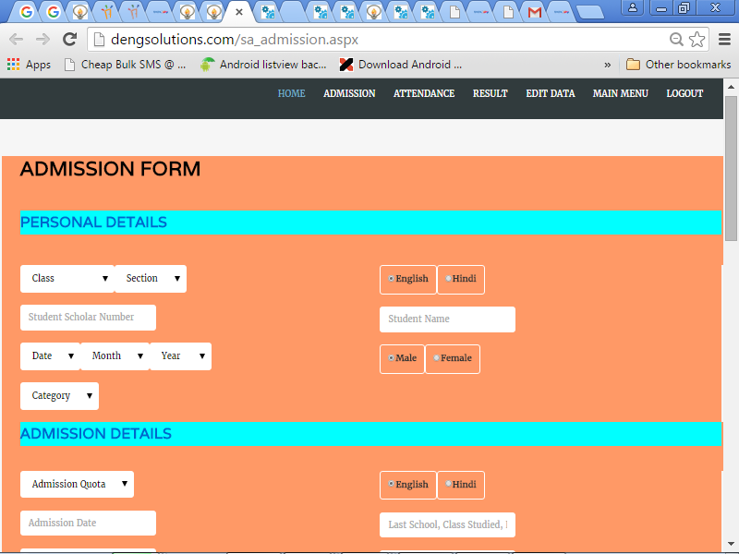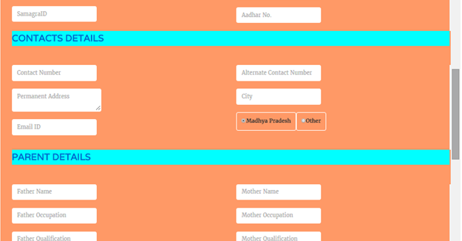

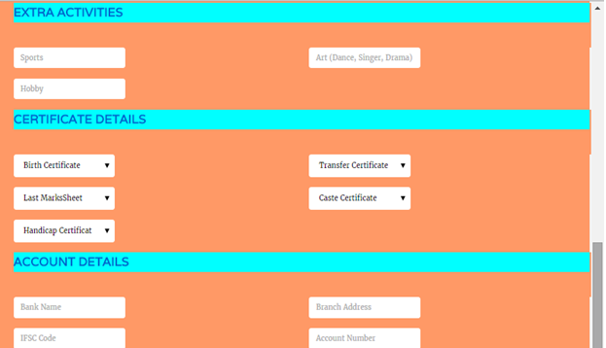

**Attendance:** Teacher can select class and section then press FIND button, a list of student get open with present check. Now by pressing submit button attendance get done. Here one report of student attendance between dates is also available where teacher enter student roll number then start and end date of the attendance then press FIND button. While DAILY REPORT button generate daily report of all the student present or absent in each class. 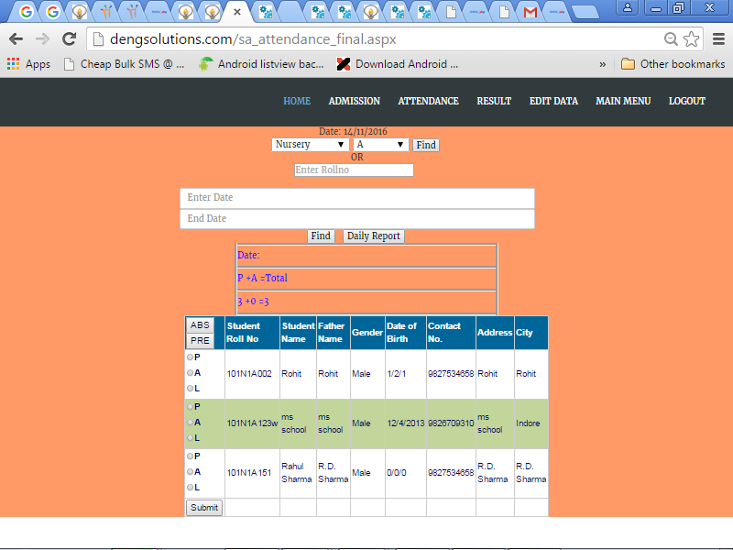

**Result Page:**

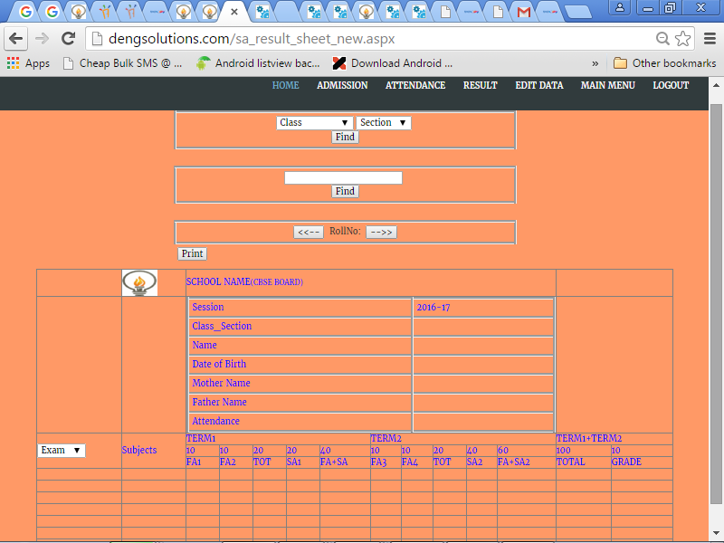

**Add Subject**: As different class have different subjects so teacher can add name of subject from this page. These list of subject is use in result and time table preparation.

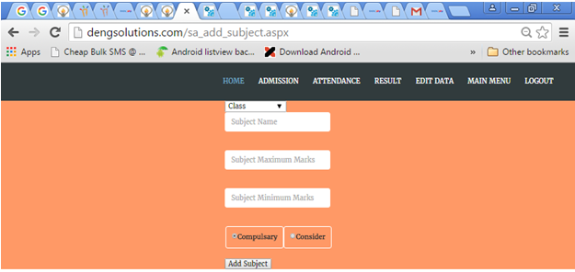

**Edit Student Data:** In order to edit the name or other details of the student one can change from this page.

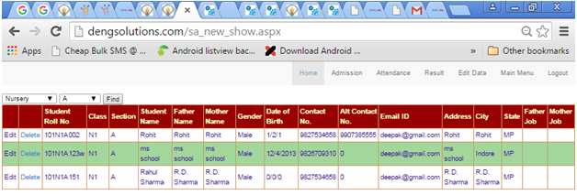

**Message Page:** In this page teacher can message the home work or any special information to the parents by just one click. Here message can be sent to whole school or class, or section, or individual student.

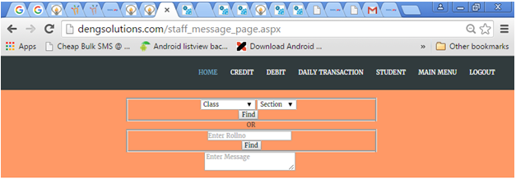

**Front Page:** This is control page for editing the NEWS, NOTICE, EVENT, ACHIVEMENT, GALLRERY Pages of the website.

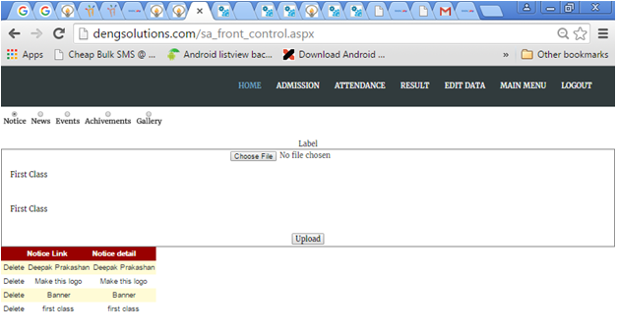

**Staff Joining:**

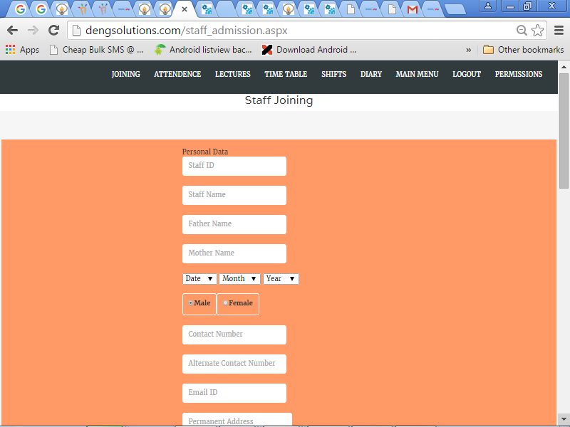

**Staff Attendance Page:**

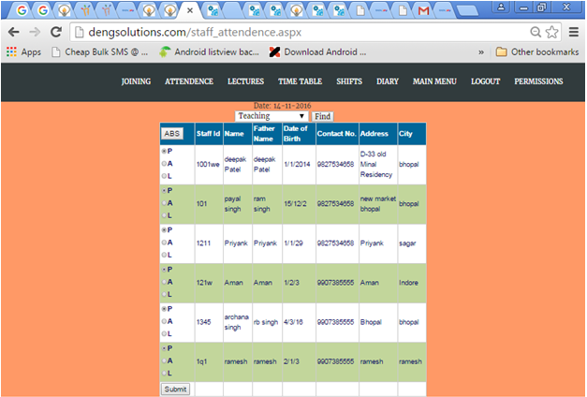

**Assign Lectures:** Here one can select shift of school then all class of that shift get open and one can set the time and lecturer name, subject for time table.

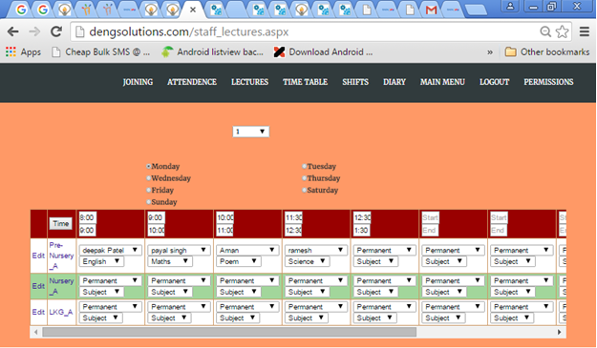

**Time Table:** Here one can get two view of time table one is daily time table and other is weekly time table of the classes.

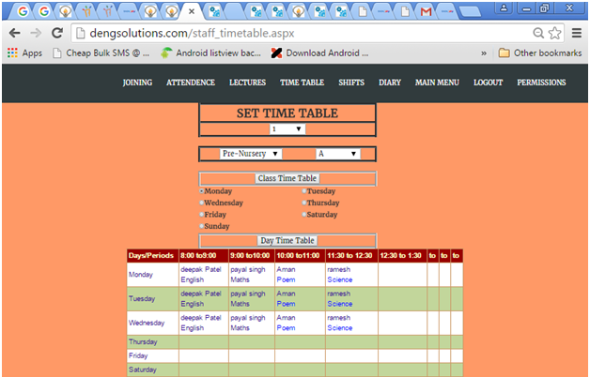

**Set Class Shift:** Here admin can change the shift of the different class as per school schedule.

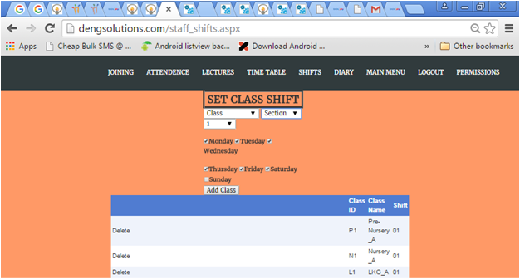

**Diary:** Here teacher can add the status of the syllabus complete by him/her.

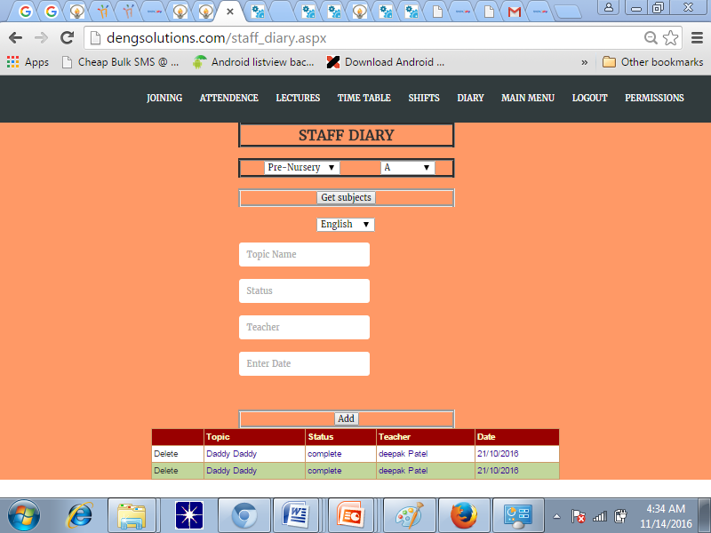

**Permission Page:** Here admin can permit different staff members various power to enter in the conrol part of the websites. If teacher do not have permission for any control then he or she cannot enter in those part of the websites.

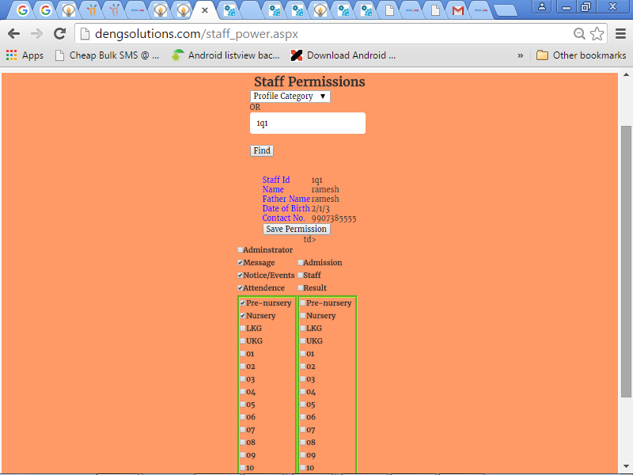

**Add Book:**

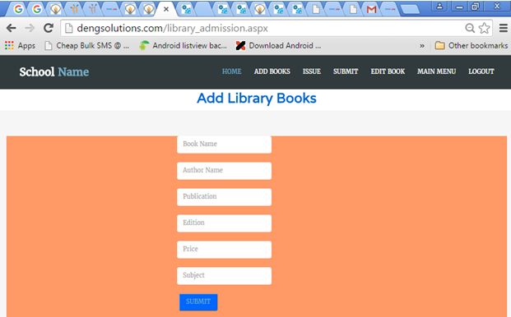

**Issue Book**

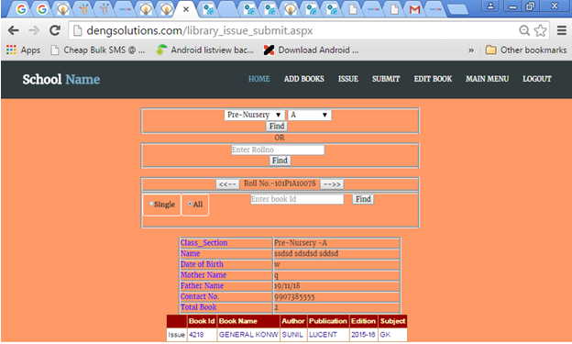

**Submit Book**

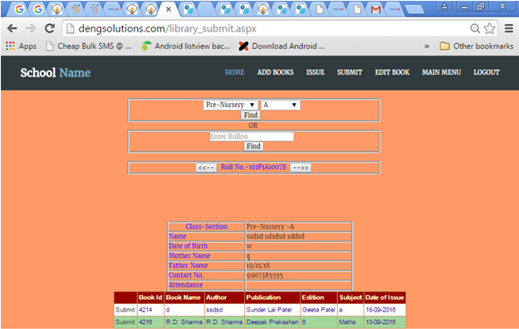

**Edit Book Details**

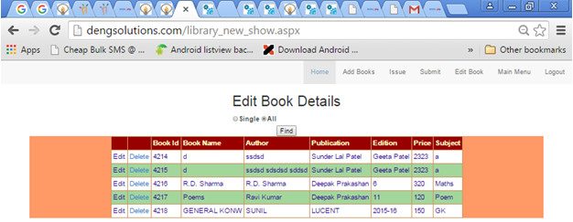

**Credit**

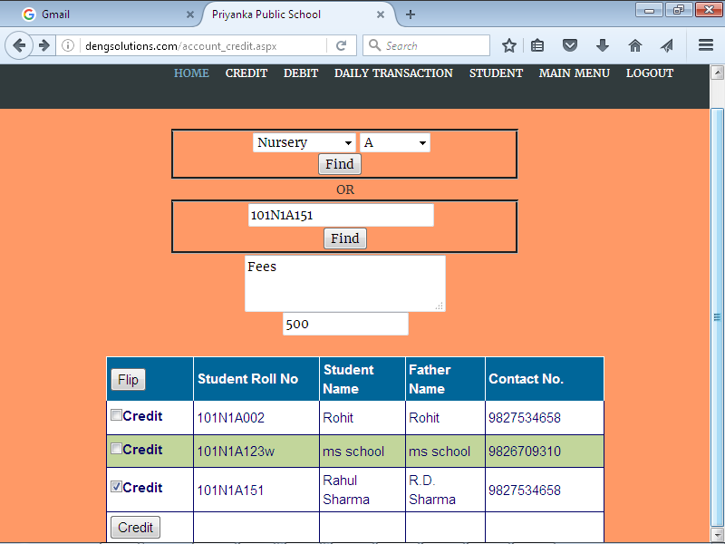

**Debit**

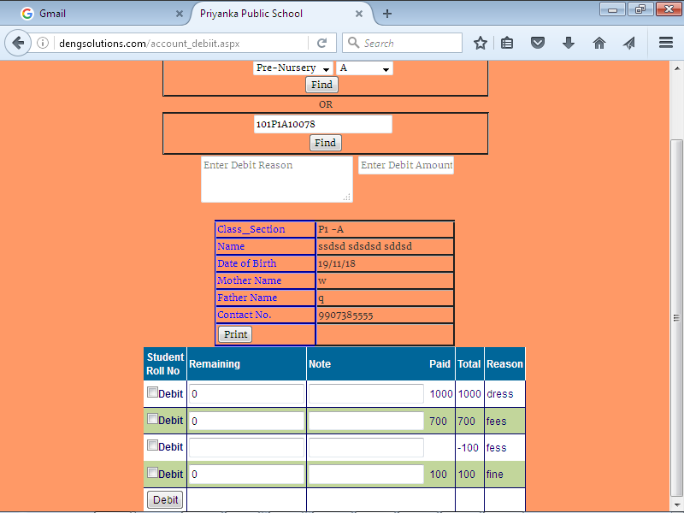

**Transaction Page:** One can get transaction details between two dates.

